Social Icon Container Component

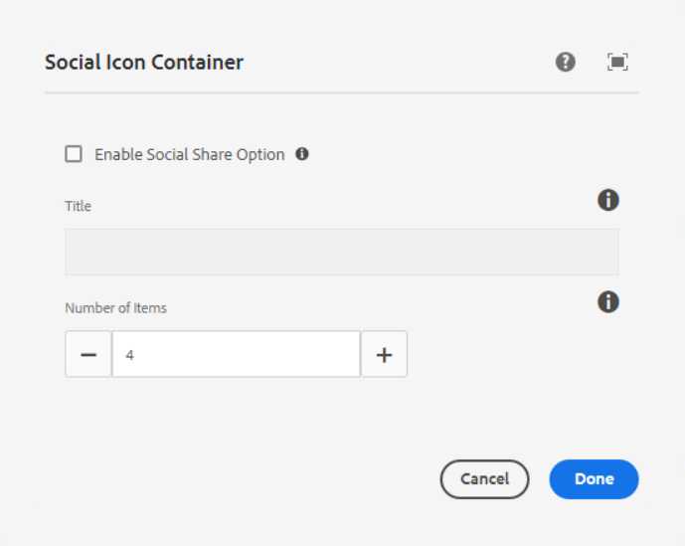

**Checkbox for Enable Social Share Option** - Check this checkbox to enable sharing option, and when we click on the checkbox then only the title field is visible.

**Title** – This is the title of Component

**Number Of Items** – Number of components to add in the container

___________________________________________________________________

Social Icon Component

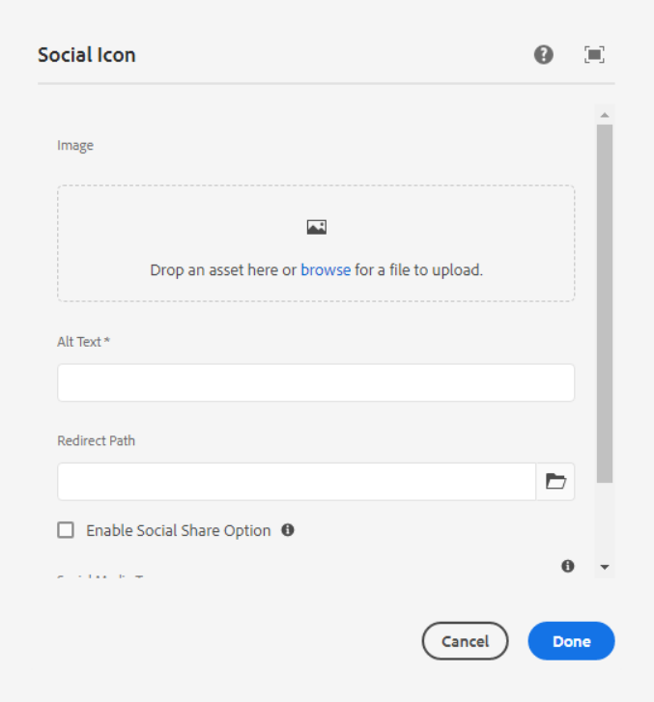

**Image** – Here we can add social icon image.

**Alt Text** – This is for alternative text.

**Redirect Path** – Here we can set redirection of social icon

**Checkbox for Enable Social Share Option** – Checked this checkbox to enable social sharing option

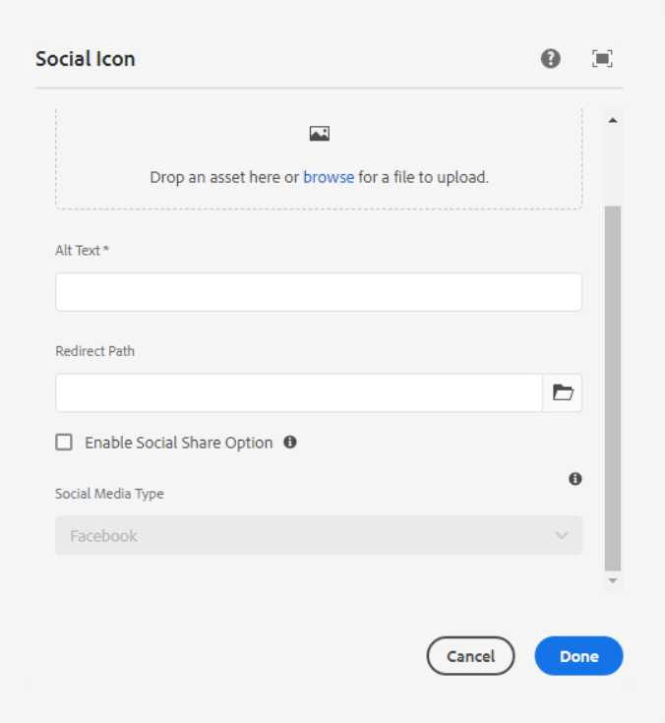

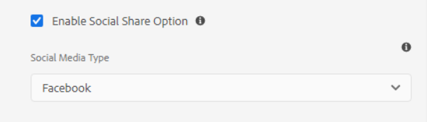

**Social Media Type** – Select one social media type from the dropdown as per the requirement.

1. Facebook
2. Twitter
3. Pinterest
4. LinkedIn

___________________________________________________________________

Below are the steps to author the footer social icon and social share icon.

**Author Footer Social Icon**

We need to author number of items as below, then 6 social icon components will be shown inside the social icon container component.

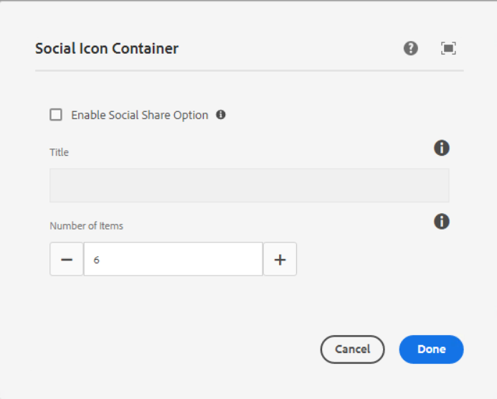

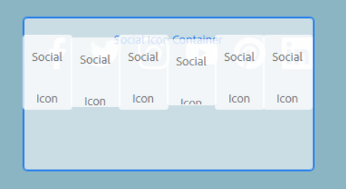

Then we need to author social icon component.

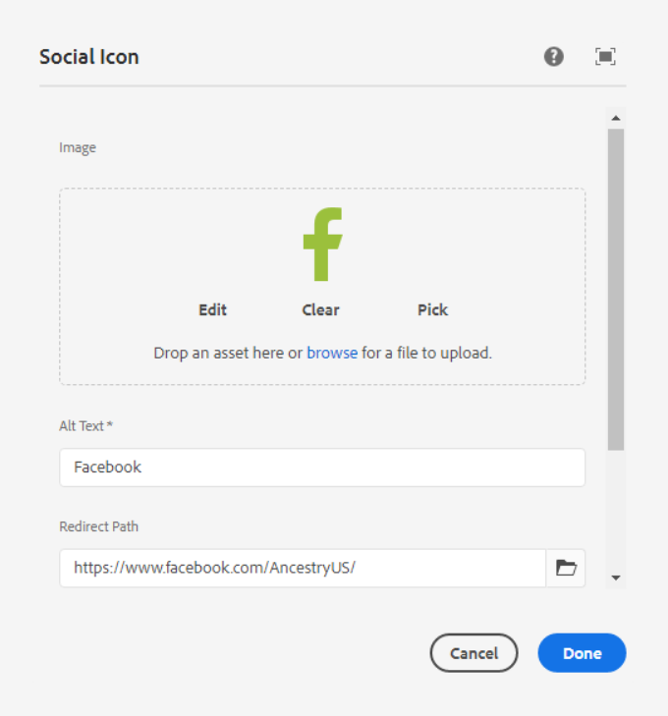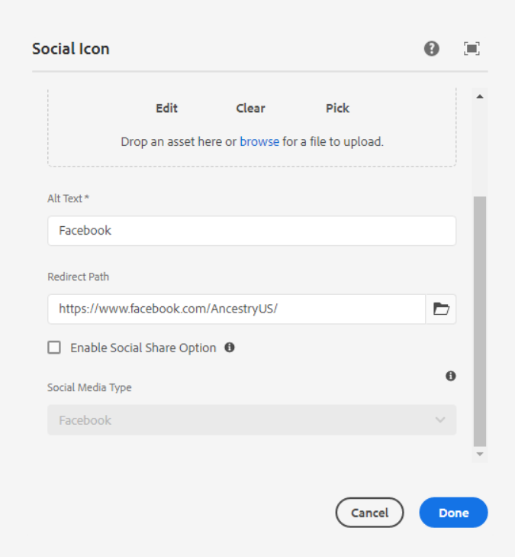

AEM URL - <https://author-ancestry-dev2.adobecqms.net/content/experience-fragments/ancestry-corp/us/en/site/footer/master.html?wcmmode=disabled>



___________________________________________________________________

**Author Social Share Icon on blog Templates**

We need to checked enable social share option then we can able to see the title field enabled, so we can able to add the title as per the below screenshot.

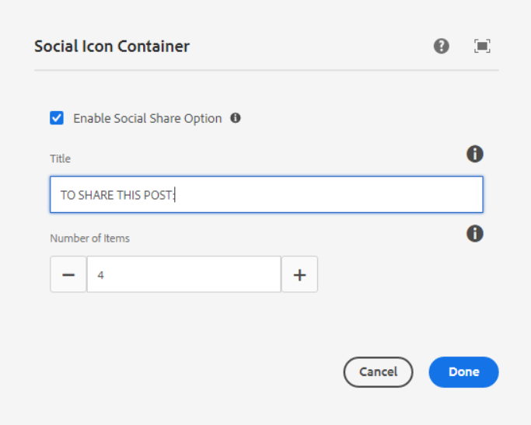

On the basis of the number of items, the social icon component will be shown in the social icon container.

For E.g. If we have added 4 items then 4 social icon component is visible after the title text, as per the below screenshot.

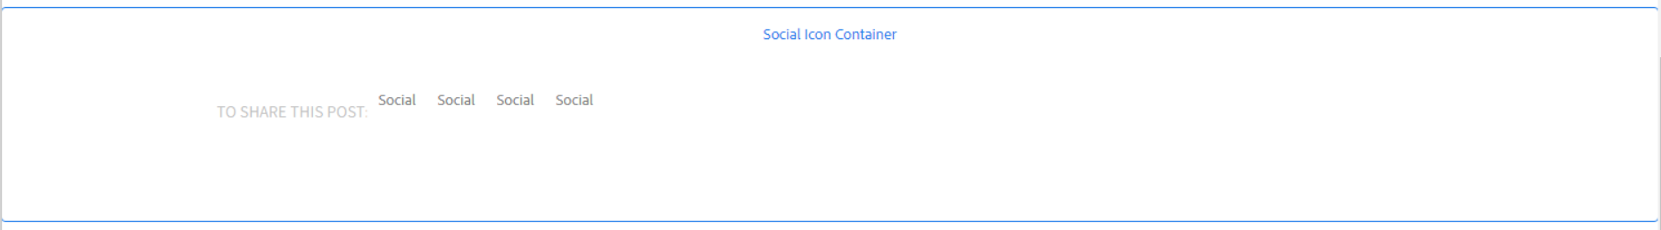

Then we need to author social icon component.

Here no need to set a redirection path, we can just check the enabled sharing option and select the social media type as below.

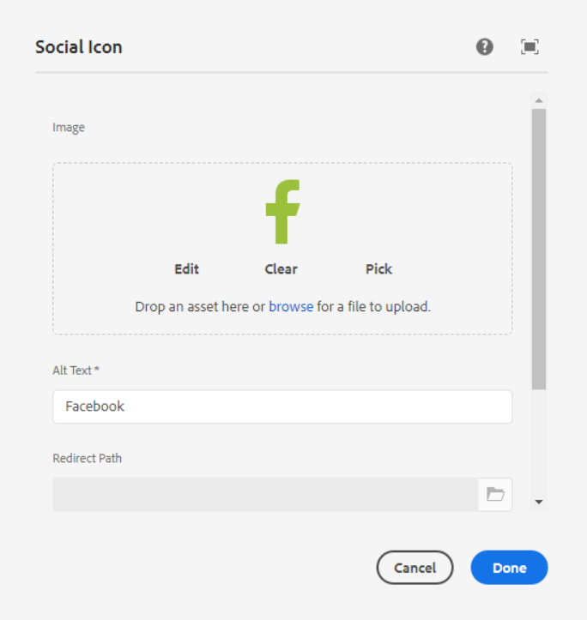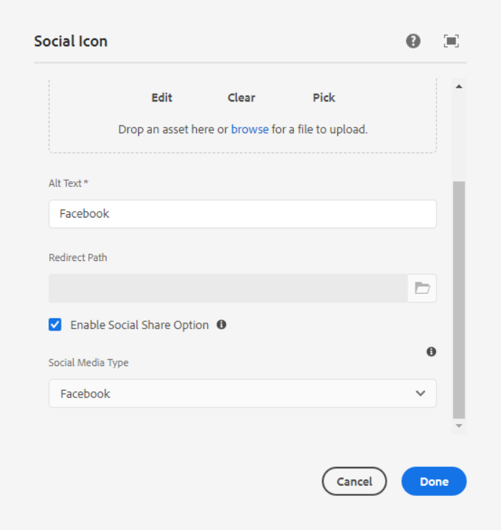

AEM Page - <https://author-ancestry-dev2.adobecqms.net/content/ancestry-corp/us/en/blog/ancestryvolunteers-ancestry-2022-global-week-service.html?wcmmode=disabled>

